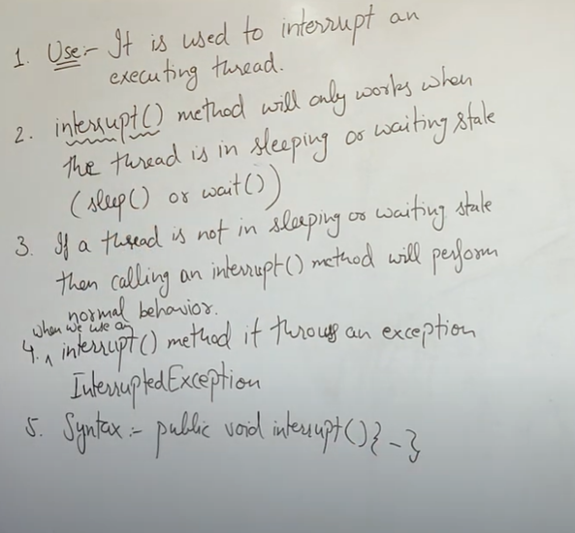

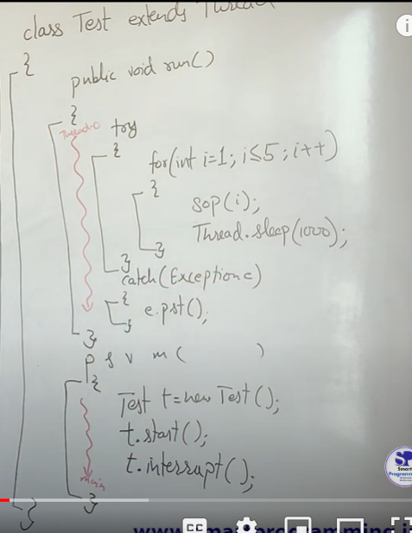

If thread.sleep() is commented out , no interrupt result will be seen . On running the program ,

Sop(1) prints 1 , then at the instant thread.sleep() method is executed , exception is thrown !!

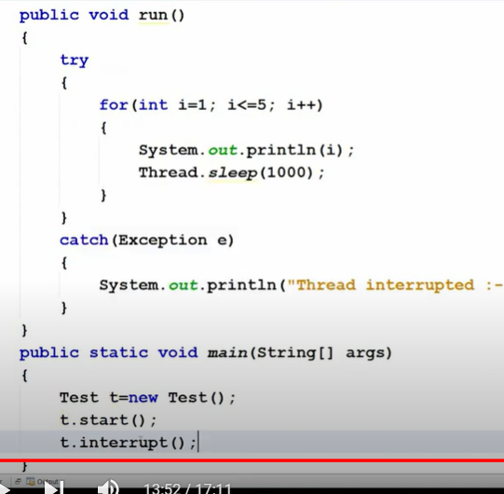

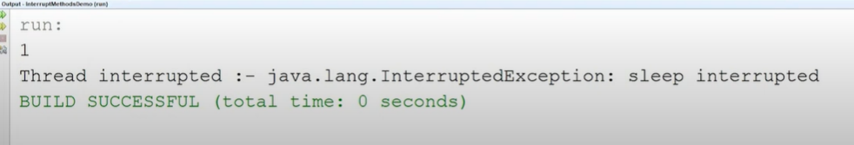

So interrupt() method is used to set interrupt flag = true;

Interrupted() , Isinterrupted() method both returns false if method is not being interrupt.

Now once you at least used Interrupted() after calling Interrupt() , then it sets flag = false permanently

But IsInterrupted() method will only return true if interrupt() is set .

q>> Interrupted(); -> changes flag

Interrupted();

IsInterrupted();

Output : true , false , false

q>> IsInterrupted();

IsInterrupted();

Interrupted();

Output : true , true , true

But it will print true and change flag status = false or stop interrupt() , After this line if IsInterrupted call() false will be prited.

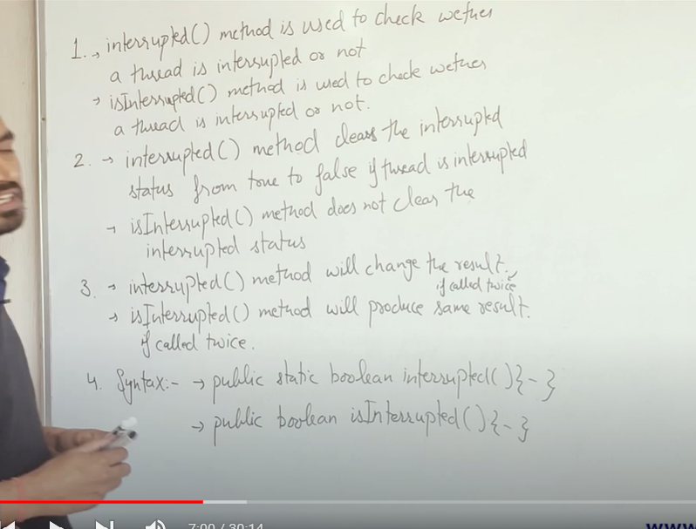

isInterrupted is not static method!!

Main method is common for every example >>

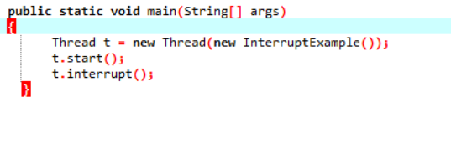

A>>

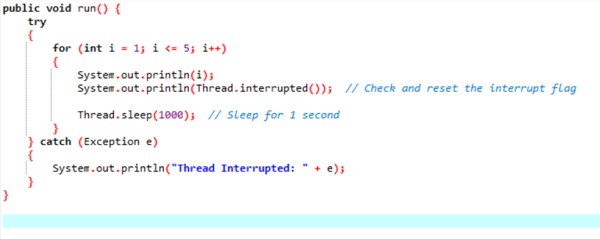

Now t.interrupt() turns the flag interrupt = true , but before it reaches thread.sleep() , interrupted() is called and hence flag changed to false.

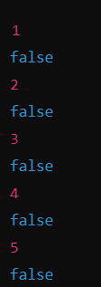

SAME RESULT IF WE PUT INTERRUPTED() METHOD ABOVE TRY BLOCK !!

Why the first print is false . Previous codes were returning true for first Interrupted() , then changed flag = false , if then we again print interrupted() , ans = false.

Reason: • **First Iteration (i = 1)**:

* The thread prints 1.
* The thread then calls Thread.interrupted() to check if it has been interrupted. Since the interrupt signal is only processed **after** this call, it returns false and prints false.
* The thread then calls Thread.sleep(1000) to sleep for 1 second.
* During this sleep period, the thread gets interrupted by t.interrupt().

So it depends on compiler / platform dependency like in eclipse it was printing true but for chatgpt it is false due to above rsn.

B>>

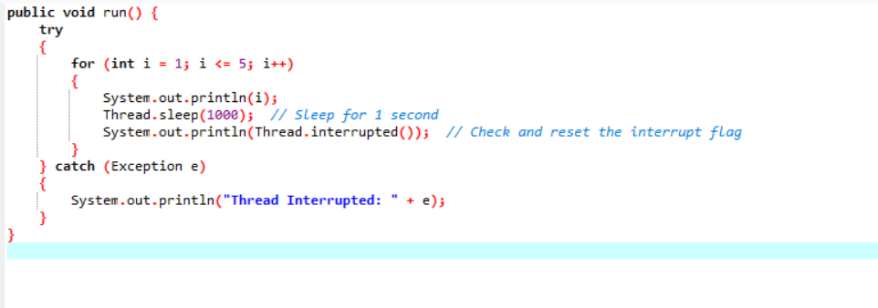

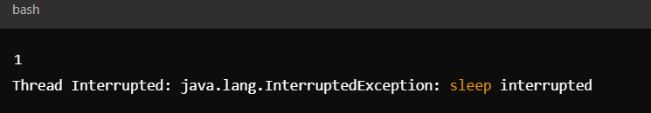

Sleep method will be executed first bfr flag status changed.

C>>ISINTERRUPTED() JUST RETURN STATUS AND NOTHING ELSE

Call : ( non – static ) Thread.currentThread().isInterrupted();

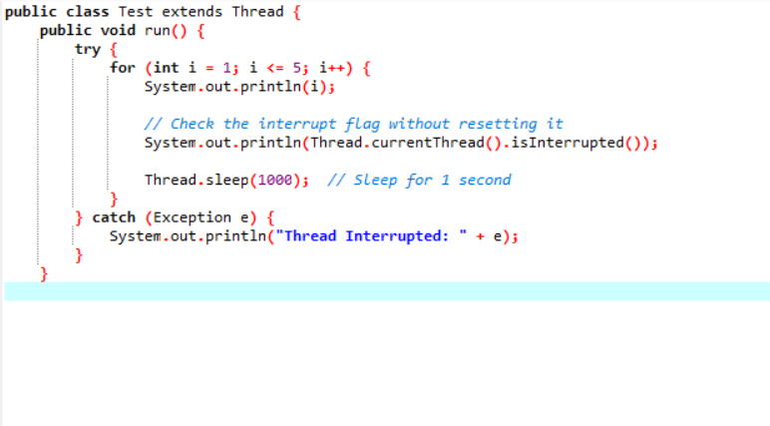

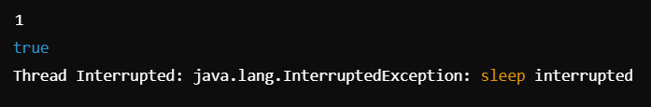

D>>

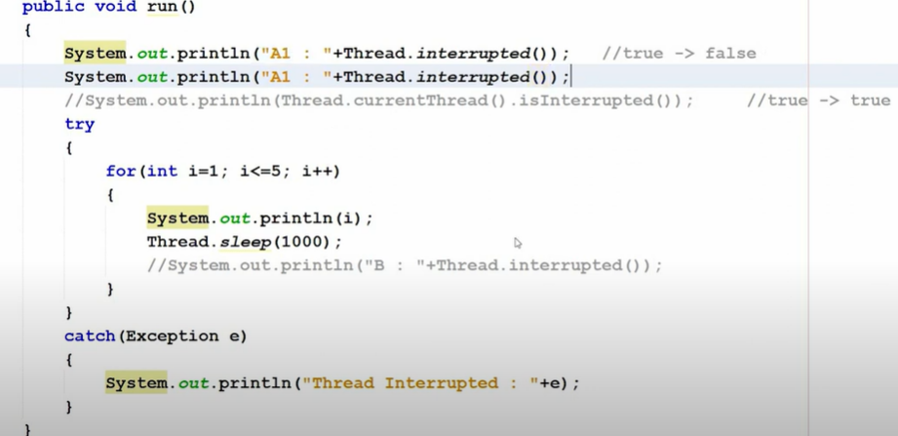

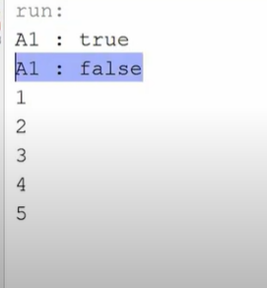

A1 : TRUE , ECLIPSE ( PRINT FIRST , THEN CHANGE FLAG STATUS )

A1:FALSE , CHATGPT(FIRST CALL FUNC AND CHANGE STATUS THEN PRINT)